**Nama : Rehanta Alpharel**

**NPM : D1A220709**

**Kelas : 7B**

**TUGAS 2**

**SISTEM INFORMASI GEOGRAFIS**

**Berikut adalah Link jsfiddle :** <https://jsfiddle.net/Rehanta/qkm5wt3g/4/>

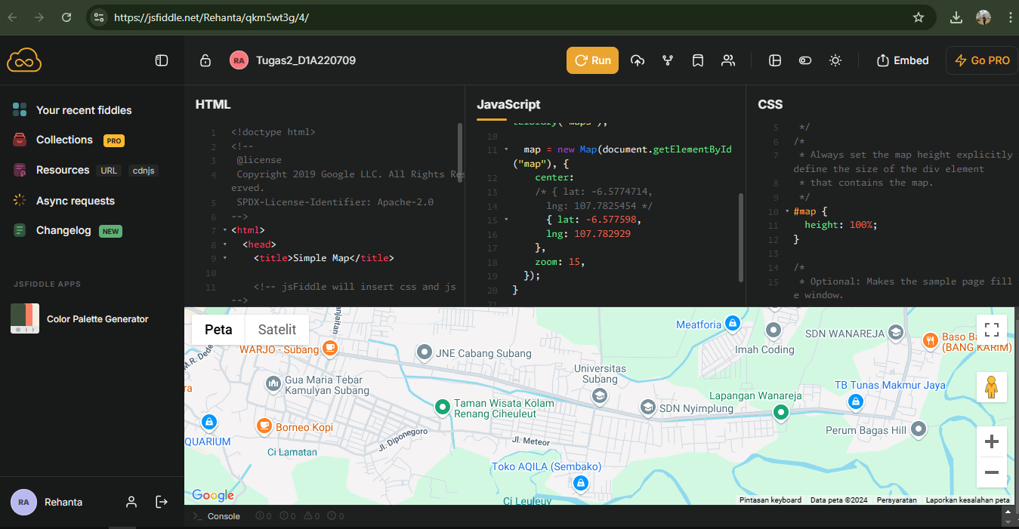

**Latitude: -6.577598**

**Longitude: 107.782929**